**10 things you (probably) didn't know about the Middle Ages**

It is one of the most fascinating periods in history, popularised by Magna Carta, the Black Death, and the Hundred Years War. But how much do you really know about the Middle Ages? Here, kicking off our medieval week, John H Arnold, professor of medieval history at Birkbeck, University of London, reveals 10 things about the period that might surprise you…

Monday 17th November 2014

Submitted by: [Emma Mason](http://www.historyextra.com/blogger-profile/emma-mcfarnon)

[Share](http://www.historyextra.com/feature/medieval/10-things-you-probably-didnt-know-about-middle-ages)

[Tweet](http://twitter.com/share?text=10%20things%20you%20(probably)%20didn%27t%20know%20about%20the%20Middle%20Ages)

[Plus](https://plus.google.com/share?url=www.historyextra.com/feature/medieval/10-things-you-probably-didnt-know-about-middle-ages)

[**BBC History Magazine - 5 issues for £5**](http://www.buysubscriptions.com/history-magazines/history-magazine-magazine-subscription?offerCode=HTWEB815&utm_medium=brandsite&utm_source=historyextra.com&utm_campaign=substorial_HTWEB815_Brand)

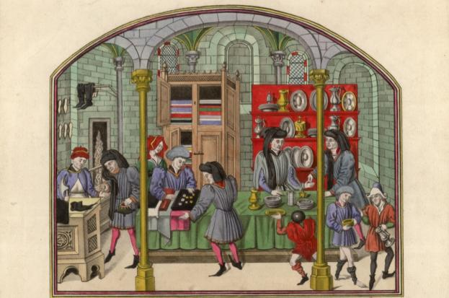

*c1450: A French 15th-century covered market showing silversmiths, cobblers and drapers selling their wares. Original artist: Bibliotheque de la Ville de Rouen. (Photo by Hulton Archive/Getty Images)*

**1) They weren’t all knights or serfs or clergy**

Although certain medieval writers described their society as divided into 'three orders' – those who prayed, those who fought, and those who laboured – that became an increasingly inaccurate picture from after about 1100.

The population of Europe increased hugely across the 12th and 13th centuries, with cities and towns getting much larger. Paris grew about ten-fold (and London nearly as much) in this period. In the cities, people had all kinds of jobs: merchants, salesmen, carpenters, butchers, weavers, foodsellers, architects, painters, jugglers...

And in the countryside, it was not at all the case that everyone was an impoverished ‘serf’ (that is, ‘unfree’ and tied to the land). Many peasants were free men – and women – and owned their own land, while others who were to some degree ‘unfree’ in fact bought and sold land and goods, much like other free men.

There certainly were poor, oppressed serfs, but it wasn't a universal condition.

**2) People had the vote**

Well, some people at least. Not a vote for national, representative government – because that really wasn't a medieval thing – but a vote in local politics. In France, in the 12th and 13th centuries and beyond, many towns and villages were run at a local level as a commune, and there were often [annual elections](http://www.historyextra.com/article/medieval/8-things-you-probably-didn%E2%80%99t-know-about-medieval-elections) for ‘consuls’ and ‘councillors’, where most of the male inhabitants could vote.

A more complex form of election and government was used in the city states of north Italy, with more tiers of elected officials. Women could not usually stand as officials, nor vote, but some of them were noted in the agreed charters of ‘liberties’ that French towns proudly possessed.

**3) The church didn't conduct witch hunts**

The large-scale witch-hunts and collective paranoid response to the stereotype of the evil witch is not a medieval, but rather an early modern phenomenon, found mostly in the 16th and 17th centuries. There were some witch trials in the Middle Ages, and these became more widespread in German-speaking lands in the 15th century, but those doing the prosecuting were almost always civic authorities rather than ecclesiastical ones.

For much of the Middle Ages, the main message that churchmen gave in regard to magic was that it was foolish nonsense that didn't work. When Heinrich Kramer wrote the infamous *Malleus Maleficarum*in the late 15th century, his motive was to try to persuade people of the reality of witches. In fact, the book was initially condemned by the church, and even in the early 16th century, inquisitors were warned not to believe everything that it said.

**4) They had a Renaissance, and invented experimental science**

When people talk about ‘the Renaissance’, they usually mean the very self-conscious embrace of classical models in literature, art, architecture and learning found at the end of the Middle Ages. This is usually taken to be one of the ways in which we moved from ‘medieval’ to (early) ‘modern’ ways of thinking.

But in fact, medieval intellectuals also had a ‘renaissance’ of classical learning and rhetoric. This was in the 12th century, and depended particularly on the transmission of works by Aristotle and other classical authors via Arabic philosophers and translators.

One of the outcomes was to prompt an enquiring and reflective approach to the physical world, and it led Roger Bacon (c1214–94), among others, to think about how one might observe and experiment with the physical world to learn more about it.

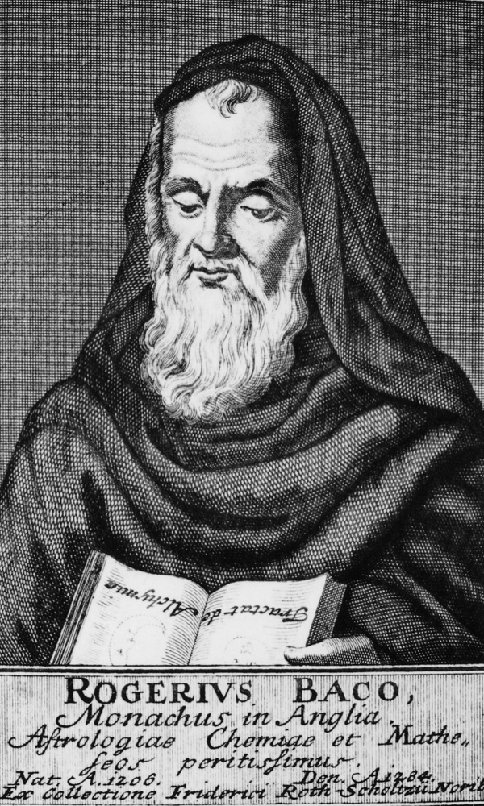

**5) They travelled – and traded – over very long distances**

It may be the case that the majority of medieval people – particularly those who lived in the countryside – rarely travelled very far from where they lived. But that would be the case with quite a lot of people in much later ages also.

It is not the case, however, that medieval people never travelled. Many went on[pilgrimage, sometimes journeying thousands of miles to do so](http://www.historyextra.com/article/culture/medieval-tourism-pilgrimages-and-tourist-destinations). And those involved in trade certainly travelled, linking parts of the world together via merchandise across extraordinary distances.

Even in the early Middle Ages, all kinds of high-status goods were transported from very distant shores to various European lands: silk from China; spices from Asia, brought to Europe via the Middle East; amber and furs from the Baltic. A few intrepid travellers even wrote journals charting their journeys: William of Rubruck’s *Journey to the Eastern Parts of the World* describes his three-year journey, which began in 1253, through the lands we now know as Ukraine and Russia.

**6) They had some great ‘folk’ customs**

Much of the public culture of the Middle Ages was shaped, or at least informed by, Christianity. But there were also some quite curious customs, usually tolerated by the church, but which may have had older roots.

One was the practice – found in many different parts of Europe – of rolling burning barrels down a hill on Midsummer’s Eve. Another was to throw wheat over the heads of a newly married couple. It was also common to raise money for charity by [holding a ‘help ale’: brewing up a batch of ale, having a big party to drink it, and collecting donations](http://www.historyextra.com/article/animals/pictures-medieval-life" \t "_blank).

There were undoubtedly a number of things that look to us like ‘superstitions’, often to do with invoking supernatural protection against disease or failure of harvest. But the Midsummer festivals, and the ales, also sound like they were a good laugh.

**7) You didn't have to get married in church**

In fact, you almost certainly didn’t get married *in* church: those who wanted their marriage ‘solemnised’ would usually do so at the gate to the churchyard. But in any case,[couples didn’t need a church, or a priest, or the banns being read, or any other religious paraphernalia](http://www.historyextra.com/article/food/love-health-and-weather-9-things-medieval-londoners-worried-about).

The church certainly wanted people to do these things: since around the 12th century it had started to argue that marriage was a formal sacrament (that is, that it involved God enacting a change within the world). But in practice, and in law, people got married by declaring clearly that they wanted to marry each other.

There had to be consent, and ideally there should be witnesses (in case either party later had a change of mind). But you could marry very simply.

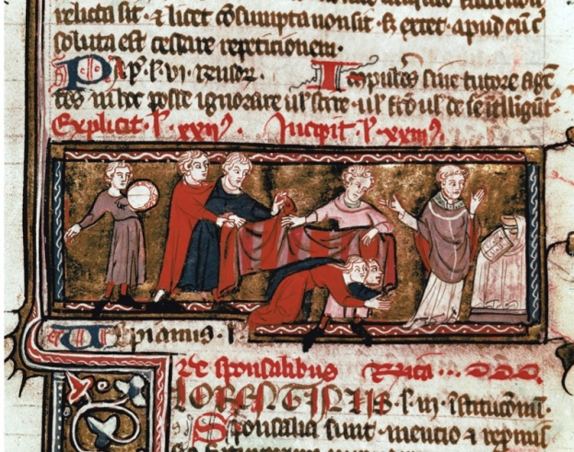

**8) Most great medieval authors didn't write**

We tend to think of literacy as one thing, but in fact it combines various different skills, of which the physical act of writing is only one. For much of the Middle Ages, working as a scribe – writing – was seen as a kind of labour, and was not something that tremendously clever, important people like theologians and intellectuals would bother doing themselves.

Instead, they would use the medieval equivalent of voice recognition software: a scribe who would write down what the author dictated.

**9) Some people weren't very religious**

The Middle Ages famously features great examples of extreme religiosity: mystics, saints, the flagellants, mass pilgrimage, and the like. But it would be wrong to assume that people were always very focussed on God and religion, and definitely wrong to think that medieval people were incapable of sceptical reflection.

There is solid evidence of some ordinary people who looked askance at particular beliefs – at the miracles performed by saints, or the nature of the Eucharist, or what was said to happen after death. A number of ordinary people decided that the soul was ‘nothing but blood’, and simply disappeared at the point of death. Others thought that there was no reason to think that it was God who made plants and crops grow, but just the innate properties of working and feeding the soil.

There is also ample evidence of people just not bothering very much with religion – most of all not [going to church on a Sunday](http://www.historyextra.com/article/medieval/medieval-graffiti-lost-voices-englands-churches-middle-ages" \t "_blank). One Spanish priest, in the very early 14th century, reported to his bishop that hardly anyone came to church on Sundays, but rather larked about in the streets playing. Other records give the sense that at least a sizeable minority enjoyed themselves elsewhere on Sunday mornings.

**10) They didn't believe the world was flat**

Most people probably know this already, along with the fact that Viking helmets did not have horns. Both are bits of Victorian myth-making about the period, along with the idea that the lord had the right to sleep one night with any newly-wedded woman.

What makes studying medieval history fascinating is that you have to grapple with both the puzzle of extracting information from difficult and often fragmented surviving records, and the challenge of constantly checking your own thinking for assumptions and inherited stereotypes.

**John H Arnold, professor of medieval history at Birkbeck, University of London, is the author *The Oxford Handbook to Medieval Christianity*(OUP, 2014). He is also the author of *What is Medieval History?*(Polity, 2008) and *Belief and Unbelief in Medieval Europe* (Bloomsbury, 2005)**